**Operating System**

**UINX Shell**

**Anshi Chhajed**

**0827CY221012**

**4th Sem**

* **Objective:** Case study of UNIX shell.

A **Shell** provides you with an interface to the Unix system. It gathers input from you and executes programs based on that input. When a program finish executing, it displays that program's output. Shell is an environment in which we can run our commands, programs, and shell scripts.

**Basic Commands of UNIX:**

* **ls-** Lists your files  
  **ls -l** --- lists your files in 'long format', which contains lots of useful information, e.g. the exact size of the file, who owns the file and who has the right to look at it, and when it was last modified.  
  **ls -a**--- lists all files, including the ones whose filenames begin in a dot, which you do not always want to see.  
  There are many more options, for example to list files by size, by date, recursively etc.

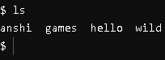

ls command is showing list of the files – “anshi”, “games”, “hello”, “wild”

* **cd-** Change directory. You basically 'go' to another directory, and you will see the files in that directory when you do 'ls'. You always start out in your 'home directory', and you can get back there by typing 'cd' without arguments. 'cd ..' will get you one level up from your current position.

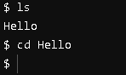

* **pwd-** Tells you where you currently are.

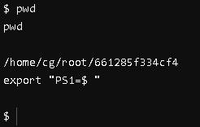

* **mkdir- *dirname*** make a new directory

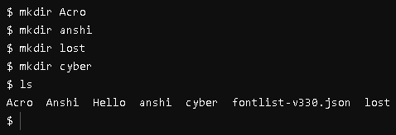

We have created multiple directories, “Acro”, “anshi”, “lost”, “cyber”.

It is confirmed by “ls” command.

* **rmdir-** The rmdir command is used in command-line interfaces to remove directories (folders).

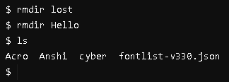

Removing “lost” and “Hello” directory and confirming through ls command.

See earlier through mkdir we made these directories and displayed through ls, now using rmdir we removed two of them.

* **touch-** Command is used to create empty files or update the timestamp of existing files in Unix/Linux systems.

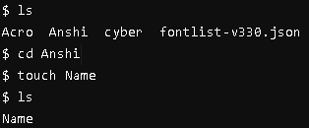

* **echo-** The echo command is used in Unix/Linux and Windows command-line interfaces to display text or print messages to the terminal. It's a simple yet powerful command for displaying output**.**



This command will add “my name is Anshi” to name file.

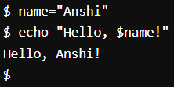

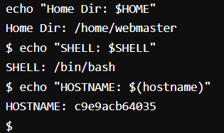

We can also get the host name, shell, home directory using echo.

* **cat-** The cat command, short for "concatenate," is used in Unix/Linux environments to display the contents of files or concatenate files and display the result.

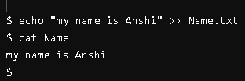

This is displaying the content of “Name” file i.e.

“my name is Anshi”.

* **cp-** To copy files and directories from one location to another.

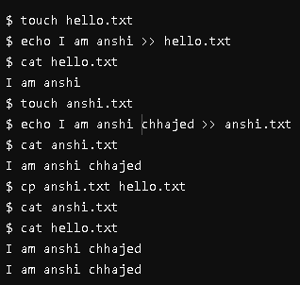

Here we have made two files “hello” and “anshi” using touch command and added some text in both.

Now, using “cp” command we will replace from anshi (source) to hello (destination).

Hello – “I am anshi”

Anshi – “I am anshi chhajed”

Using co we replaced the content of hello with anshi.

Now hello- “I am anshi chhajed”

* **grep-** The grep command is a powerful tool used in Unix/Linux environments and Unix-like operating systems for searching text patterns within files or streams.
* **grep-i:** This command performs a case-insensitive search for the specified "pattern" within the "filename".
* **grep-w:** This command searches for whole word matches of the specified "pattern" within the "filename".
* **grep-c:** This command counts the number of lines that contain the specified "pattern" within the "filename".

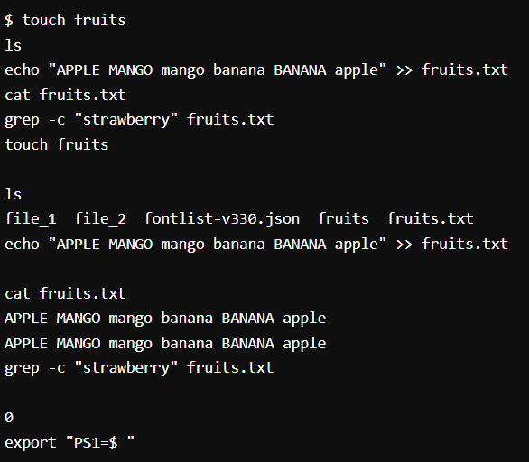

Create a file “fruit” and add “APPLE MANGO mango banana BANANA apple”.

Using grep-c we ca find the number of words.

Here we used “strawberry” as it wasn’t in the file therefore the count was zero.

* **Script for adding prefix to old file name:**

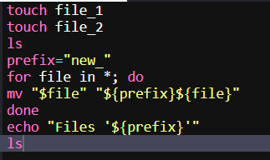

Created two files “file_1” and “file_2” then add “new_” as the prefix to all the files.

As result, first the name of the files of was “file_1” and “file_2” and after the prefix file name change to: “new_file_1” and “new_file_2”

